- Home
- What is eDemocracy?
- Why eDemocracy?
- Role of Government
- Challenges
- Project Blog
- Contact

What is eDemocracy?
Establishing a clear and comprehensive definition of eDemocracy is a difficult task. It is a term of two components; ‘e’, which signifies the online component, and ‘democracy’, which refers to a theory and system of governance. While this may, at first glance, appear to be an obvious statement to make, it in fact underpins the complexity of the concept. eDemocracy is a relatively new notion and remains somewhat fluid due to its fundamental relationship with technology and the internet – fields that are themselves ever-changing, and somewhat unpredictably so. Any outline of precisely what constitutes the ‘e’ of eDemocracy is thus at risk of obsolescence within a short time-frame. Moreover, ‘democracy’ is a broad category under which a number of theories can be subsumed. Though eDemocracy, amongst the relevant literature, is predominantly linked with and informed by deliberative conceptions of democracy, it can also be linked with more liberal-individualist or pluralist approaches.
The definition of eDemocracy has also been muddled by haphazard discussion of the related but distinct term of ‘eGovernment’. eDemocracy and eGovernment are not synonymous; in fact, it would be more appropriate to consider eGovernment as part of eDemocracy, which is a much more broad and encompassing collection of ideas. eGovernment, as Chadwick and May explicate (p. 2), is principally concerned with “the ‘efficient’ delivery of government information to citizens” and, despite the opening up of some public service information, state control remains as “the defining logic.” It therefore maintains the circumstances of the offline world, where government-citizen interaction is hierarchical and top-down in nature. In contrast, eDemocracy builds upon eGovernment initiatives such as online service delivery and open access to information, incorporating civic engagement and civic education. It is concerned with distributing control and decision-making power through fostering horizontal and multi-directional connections between citizens, the third sector, and government.
It is perhaps easiest to outline the concept of eDemocracy with the assistance of a diagram. (Please excuse my poor graphic design skills and reliance upon Power Point Smart Art!)
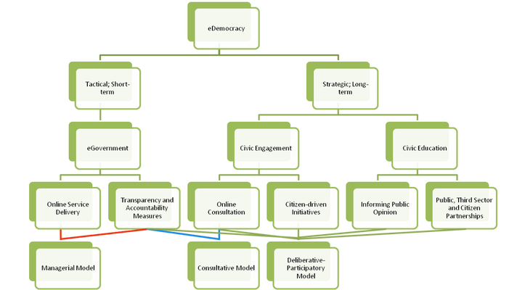
For a larger version, please click here.
Short-term; Long-term
eDemocracy can firstly be broken down in to two components – the ‘tactical’ or short-term, and the ‘strategic’ or long-term. Short-term measures are those that are predominantly focused with significant, but somewhat conservative changes. In effect, they are making slight alterations at the fringe, rather than introducing the more pervasive and fundamental changes that constitute the long-term or strategic aspects of eDemocracy. eGovernment initiatives are best categorised under the short-term banner; eGovernment is largely perpetuating the top-down nature of government-citizen interaction, albeit improving the quality of that interaction quite substantially. Moreover, eGovernment reform can often be justified by easily-quantifiable benefits, such as cost reductions through online service delivery and the adoption of basic, technology-enabled ‘smart work’ practices (for a more thorough discussion of ‘smart work’, please see the ‘Role of Government: Internal’ page). On the contrary, civic engagement and civic education requires not only consistent and extensive political commitment, it also necessitates a political culture that pursues policy with benefits that may not manifest within the space of one electoral cycle, and those benefits themselves may not be easily quantified.
eGovernment
eGovernment, unlike eDemocracy, is somewhat simple to define. The United Nations Division for Public Economics and Public Administration provide a concise explanation (p.2) – albeit with some outdated phrasing – describing eGovernment as “utilising the Internet and World Wide Web for delivering government services and information to citizens.” Rachel Silcock (p. 88) provides a more expansive and accurate description, contending that eGovernment is the “use of technology to enhance the access to and delivery of government services to benefit citizens, business partners and employees.” Moreover, it “has the power to create a new mode of public service where all public organisations deliver a modernised, integrated and seamless service for their citizens.” Both definitions, however, either disregard or underemphasise the role of eGovernment in promoting a culture shift amongst government and the public service. That is, in the area of open governance and the associated free and accessible distribution of government data and public service information (PSI).
eGovernment is a critical aspect of eDemocracy, providing a foundation through open government and transparency initiatives towards a more informed, active citizenry that is more capable of holding its public officials to account. Former British Prime Minister, Gordon Brown, proclaimed in his ‘Smarter Government’ speech of 7th December 2009 that eGovernment was the “next stage of public sector reform.” Similarly, amongst Barack Obama’s first Presidential memoranda were declarations of open governance and more innovative utilisation of technology to enable greater transparency, citizen empowerment through information, and improved service delivery. Unsurprisingly, given these announcements from the respective heads of government, the United Kingdom and United States have been at the forefront of eGovernment initiatives, the most prominent of which have been the data sites of data.gov.uk and data.gov. Demonstrating the influence that progressive policy can wield, the UK and US have also witnessed a flourishing of info-philanthropy and third sector PSI initiatives. For example, Fix My Street, They Work For You, Every Block, Open Congress, MAPLight, The Redistricting Game, and the Sunlight Foundation.
Civic Engagement
Civic engagement is aimed at fostering an empowered citizenry through providing the means necessary for citizens to participate in decision-making. It attempts to reverse the trend toward centralised state power, instead promoting community-driven policy and the ideals of active citizenship and civic duty. Civic engagement is an approach to governance that draws upon ‘strong’ notions of democracy and more ‘active’ notions of citizenship, and thus is reliant upon the successful cultivation – amongst both citizens and government – of respect and acknowledgement of civic responsibility. Given this, fundamental to the notion of individual and community empowerment is a capacity for citizen participation to wield significant influence over the agenda-setting, policy-formulating and service-delivering processes. As Johnson [1] (p. 138) explains, empowerment is signified by “a disruption of pre-existing power structures and relations in a policy area.” In essence, if civic engagement is pursued, it must be pursued consistently and comprehensively; feigned interest, poor implementation, or lack of follow-up by a government or public agency is counter-productive.
Within the scope of eDemocracy, civic engagement can be segmented in to two categories – consultation and citizen-driven initiatives. Consultation incorporates citizen participation into a pre-determined agenda, where individuals or communities are able to provide feedback on areas largely defined by apparatuses of the state. For example, tools such as online surveys, discussion boards, social media, the solicitation of written feedback or submissions, and so on. In contrast, citizen-driven initiatives allow for the recognition and consideration of issues that popularly conceived and promoted. This can occur through online petition, citizen referenda, crowdsourced policy, discussion boards, and a variety of Web 2.0 software such as User Voice or Idea Scale.
Civic Education
If a government is committed to empowering its citizens and communities, said government should necessarily possess equal dedication to informing popular opinion and facilitating civic education. Yet in many cases where engagement through online consultation or similar measures has been introduced, there has been a disturbing lack of dedication from governments towards improving the understanding of those people they supposedly wish to engage. Such indifference threatens to undermine any movement towards greater citizen participation in the decision-making process; after all, a citizen cannot meaningfully influence the way in which he or she is governed unless that citizen possesses the capacity to exploit any opportunities for involvement. Without the provision of a fair and equitable platform from which all relevant interests can be addressed, rather than dominated or disregarded, civic engagement – online or otherwise – merely serves to perpetuate the status quo of a political process predominantly shaped by well-financed and organised interest groups. Additionally, it exacerbates the divide in civic and political activity along the lines of education, income and age.
It is this aspect of eDemocracy that most heavily draws upon the deliberative democracy discourse, and as such is also the aspect most critical of the current state of democracy and distribution of political and communicative power. Yet, eDemocracy does not necessarily exist outside of the representative democracy framework, nor is a liberal conception of citizenship thoroughly abandoned. Furthermore, the notion of civic education does not suggest that the government take responsibility for supplying information to citizens; rather, the government must play the role of enabler or facilitator, providing individuals with easier access to the ideas of experts, representatives, and other citizens, in a diverse and accessible manner.
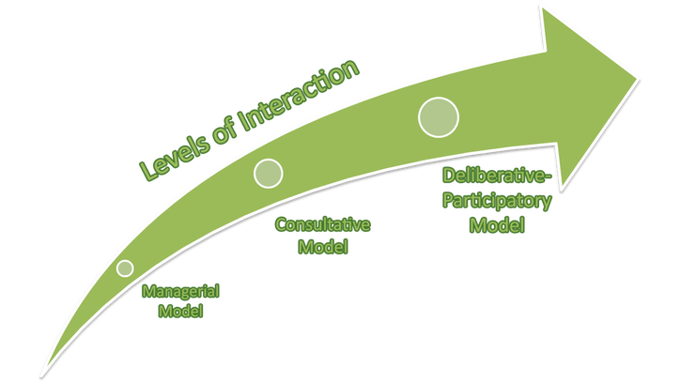
Managerial Model
As the two graphics above demonstrate, eDemocracy consists of three overlapping models that can be distinguished by levels of interaction between the state, citizens, and the third sector. While any of the three models could potentially be pursued in isolation, it is only when the online service delivery of eGovernment is combined with the Deliberative-Participatory model that the full range of eDemocracy has been realised. The managerial model is, in essence, eGovernment as described above. To expand on eGovernment, however, the managerial model involves the possession of a specific approach to, and view of, technology – in particular, information communication technologies (ICTs). Governments or agencies adopting the managerial approach view new ICTs as merely “quantitative improvement on previous technology” that will allow services to largely “continue on as before, but will be made more ‘efficient’” (p. 6). That is, where ‘efficiency’ is defined as “increased speed of delivery combined with reduction in costs.” (p.6)
The introduction of effective eGovernment initiatives is a positive step forward for any state. Yet, at the core of the managerial model is preservation of the status quo in terms of the role of government. Information, while made more accessible, remains unilinear in nature, where the audience – citizens – are perceived as “passive recipients rather than interlocutors.” (p. 7) The information itself is entirely state-generated, rather than the result of deliberation, and with the onus entirely upon the user to decipher and make practical use of it. Overall, the benefits of eGovernment should not be overlooked. However, implementation of a managerial model at the exclusion of consultative or deliberative-participatory models is a disregard for opportunities towards the enrichment of democracy and the harnessing of citizen expertise, enthusiasm, and innovative spirit.
Consultative Model
The consultative model draws together the transparency and open data measures of eGovernment with online consultation. Online consultation, as outlined in the Civic Engagement section, can incorporate a range of initiatives that leverage ICTs and innovative software to enhance interaction between the state and citizens. If the managerial model can be considered a top-down ‘push’ model, then the consultative model begins the transformation towards ‘pull’; information starts to come from citizens to the government as frequently, if not more so, than the reverse. This model integrates an acknowledgement of the influence a scarcity of resources or information can wield upon an individual’s or community’s capacity for influence over the way in which they are governed. Yet, except in its more critical manifestations, the consultative model still entails a view of information as a passive resource; that is, consultation largely occurs only within the parameters defined by a government or public agency, with any discursive questioning of the legitimacy of those very parameters being ruled out ab initio.
The consultative model, particularly in more critical forms, will also begin to highlight the issues of the digital divide and the remaining susceptibility of consultation to disingenuous tactics by special interest groups. Online consultation will generally provoke activity from self-selected citizens that represent particular socio-economic, cultural, age and educational backgrounds. Moreover, an emphasis on preference aggregation remains – in contrast to a focus on the justification and transformation of preferences through informed deliberation. As such, little government activity is harnessed towards fostering a digitally-connected and informed citizenry, where participation can take various forms dependent upon the needs and desires of individual citizens or communities. Nor are adequate structures always in place to guarantee against the distortion of consultation processes – for instance, special interest groups ‘spamming’ or ‘rushing’ forums, surveys, polls, or other tools en masse with simple declarations of opinions, rather than distinct opinions backed by cogent argument and justification. Overall, the consultative model is an upwards movement along the scale of citizen-state interaction, reaching two-way communication, yet it continues a somewhat narrow and unilinear approach.
Deliberative-Participatory Model
The deliberative-participatory model of eDemocracy is the most encompassing and, when combined with online service delivery, constitutes the full breadth of the broad concept. As Chadwick affirms (p. 14), while the consultative model “stresses the vertical flows of state-citizen communication, the participatory model conceives of a more complex, horizontal and multi-directional interactivity.” Within this model, the state is accepted only as one of many sources of information, with a role more in line with facilitator than authoritative agenda-setter. Moreover, the government actively fosters the enrichment of civil society through encouraging committed citizenship, establishing state-citizen-third sector partnerships, embracing open and transparent governance, and recognising that knowledge is discursive and amenable through interaction. The model is heavily focused upon both civic engagement and education, and therefore requires the greatest reforms to liberal democracy. Yet while aspects of deliberative democracy and stronger notions of citizenship inform this model, it does not demand the replacement of representative democracy; rather, it demands the expansion of it.
Within the deliberative-participatory model, pervasive citizen interactivity and reconciliation of divergent viewpoints are perceived as necessary components of democracy itself. While diverse communication does already take place both offline and online, some of which involving critical reflection and rational debate, there is a tendency towards people only associating with like-minded individuals. Accompanied with the dominance of liberal-individualist styles of political and civic websites, and Web 2.0 developments that allow high levels of information source customisation, this tendency has only increased in recent years. The following TED talk from Eli Pariser does an exceptional job of explaining this trend:
And for a talk on a similar concept, but from a global perspective:
The role of the state – explained in more detail here – is therefore not only to provide citizens with the opportunity and capacity to influence government, but also to encourage the interaction of competing ideas, experiences, and opinions. Additionally, the way in which this is achieved is as much determined by civil society as the state itself, allowing for a genuine deliberative public sphere where government is truly reflective of the will of the people.
[1] Johnson, G. F., 'The Limits of Deliberative Democracy and Empowerment: Elite Motivation in Three Canadian Cases', Canadian Journal of Political Science, vol. 44, no. 1, 2011, pp. 137-59.

